**Project Report**

|  |  |
| --- | --- |
| **Title of project** | House Rent Management System |
| **Team Members (ID and Name)** | 1. Kazi Nuzhat Tasnim (2014-1-60-005) 2. Nusrat Jahan (2014-1-60-035) 3. Tazin Ahmed (2014-1-60-105) |

**Abstract:**

Day by day, the use of technology is increasing and our life becomes digitized. With the current condition in technological field, Housing sector remains vigilant to face the challenges of change by employing a new strategy that facilitates easy management of rental houses. Hence there is need to develop a rental house management system that can simplify work for the rental managers and renters so that all their work can be efficient and effective.

**Introduction:**

Rental house management has become important factor in modern society hence the need to have a rental house management system. The focus of this project is basically managing housing and payment process for renters and to help owner to rent his house. It also helps the owner to track his house rent amount. The project is designed in a way that permits only classified users to show team view and count the vacancy.

**Objectives:**

The objectives of Rental House Management System are as follows:

1. To manage affordable housing for renters.

2. To help the owner to rent his available house easily.

3. To develop a rental house management system that allows the owner to view customers‟ data as well as houses record.

4. To provide an opportunity to keep the entire track about the rent and owner income systematically by owner.

5. To help the renter to pay their rent bill easily.

**Scope of the software:**

As a whole the system is focused to work with house rental system, it can be used as management systems of similar organizations.

## Requirement Analysis: Requirements may be functional or nonfunctional and both are essential to a successful software project. They are:

## Functional Requirements: This is a necessary task, action or activity that was accomplished. The proposed system is able to:

1. Register method.
2. Login.
3. Keep user records.
4. Add house details.
5. Payment options.
6. Track user’s information.
7. Deleted renter by owner.
8. Search option.
9. Message option.
10. Pop up message.
11. Admin panel.

**Non Functional Requirements:**

* + Should have different registration windows for users.
  + Should have different login windows for owner and renter both.
  + Every user id should be unique.
  + System can handle only one operation at a time.
  + Renter can search rent home and pay the rent.
  + Owner should be able to see rent related information.
  + Users can send message to the system admin.
  + Only system admin should be able to count the rent vacancy.

**Database Design(ER Diagram):**

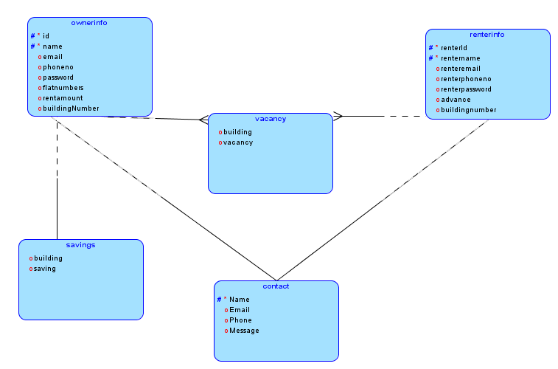

Figure : logical model

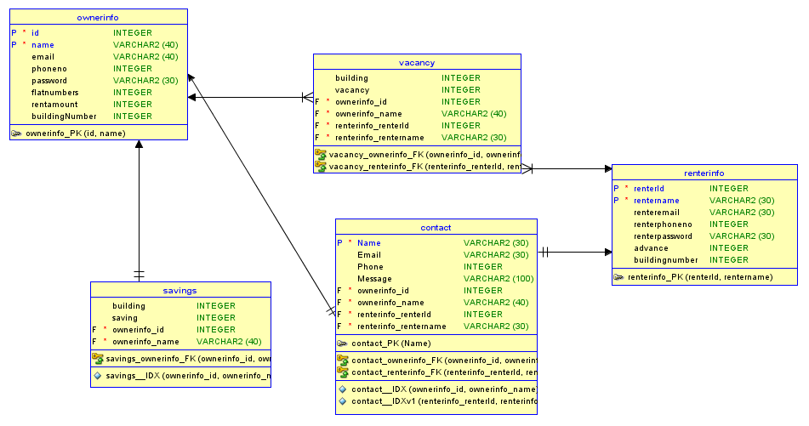

Figure : Relational model

**System Layout Diagram (Use case and Class diagram):**

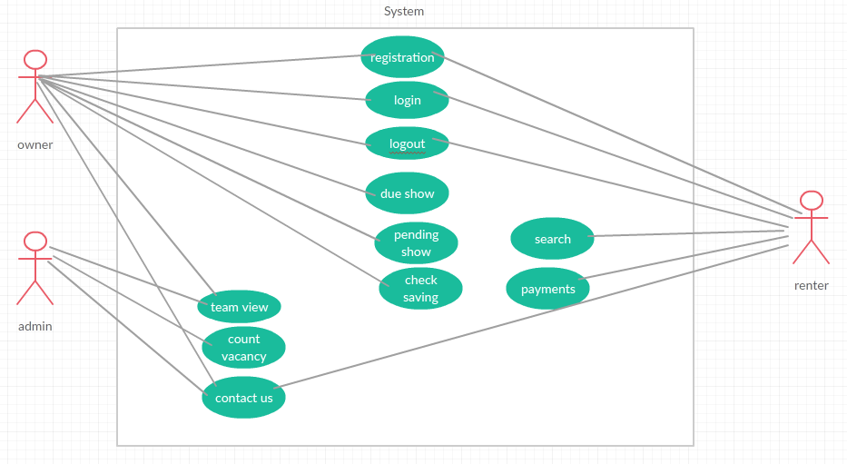

Figure 3 : Use case diagram

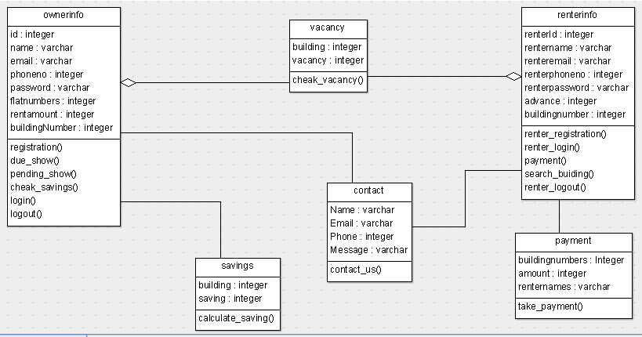

Figure 4: class diagram

**System Requirement:**

* System works properly in local host.
* The system connected with local host PHP my admin.

**Software requirement:**

* XAMPP Control Panel
* Notepad++

**Packages, APIs and libraries used:**

**Screen shots of Project:**

**Future plan:**

The future plan of this system will be more specific location wise search option and separate the flat numbers to distinguish the specific renter.

**Conclusion:**

In conclusion, the system can be used as an inventory system to provide a frame work that enables the owner to access rent related information and helps renter to find rent and pay the rent bill within a limited time frame. Each transaction made on the system with the data being updated in the database.